FRE 501

Assignment 1

Due October ?, 2021 at 11:59 pm in Canvas

Question 1

The supply of ethanol (billions of gallons) is given by $Q_{S}^{E}=11+3P^{E}-1.5P^{C}$ where $P^{C}$ is the price ethanol in $/gallon, and $P^{C}$ is the price of corn in $/bushel. Producing one gallon of ethanol requires 0.4 bushels of corn. The feedlot demand for corn (billions of bushels) is given by $Q_{F}^{C}=17.5-2P^{C}$. The supply of corn is 15 billion bushels.

1. Let $Q_{E}^{C}$ denote the demand for corn used in ethanol production and $Q_{D}^{C}$ the total demand for corn. Use substitution to calculate the equilibrium price of corn as a function of the price of ethanol.
2. Set the price of ethanol, $P^{E}$, to $2.25/gallon. There are now four variables in the system: $Q_{S}^{E}$, $Q_{E}^{C}$, $Q_{F}^{C}$ and $P^{C}$. There are also four equation: (1) the supply of ethanol; (2) the conversion equation, $Q_{E}^{C}=0.4Q_{F}^{C}$; (3) corn demand for feed; and (4) market clearing in the corn market: $Q_{E}^{C}+Q_{F}^{C}=15$. Write this system as a matrix $Xβ=Y$ where $β$ contains the four variables. Use the matrix tools in Excel or R to solve the system. Report the equilibrium corn price, and the fraction of the 15 billion bushels of corn which is used in the production of ethanol.

Question 2

Part (a)

This question is based on the following paper and the data published with the paper:   
Bonilla Cedrez C, Chamberlin J, Guo Z, Hijmans RJ (2020) Spatial variation in fertilizer prices in Sub-Saharan Africa. PLoS ONE 15(1): e0227764.

The fertilizer in question is urea nitrogen. Variables of interest are as follows: ppp_price_kg (adjusted fertilizer price, US$); distPort (hours of travel to nearest port); popD and ral_pop (population and rural population density, persons/km2); prec (annual precipitation); crop_ha (a measure of cropland); and nat_avg (the average price across all observations in the country). The data was filtered for three years: 2011, 2014 and 2017.

For this question you will require the following R packages: dplyr, ggplot2 and mapdata.

Your first job is to read “fertilizer_data.csv” into R. You must then subset your data as follows: choose one year for the analysis (2011, 2014 or 2017) AND choose one region for the analysis (latitude > 4.75 🡺 northwestern Africa or latitude < 4.75 🡺 southeastern Africa).

Then create a vector consisting only of the country names. For example, for the specific case of year == 2017 and latitude >4.75 the country list should look as follows:



You can now use R’s map_data() function to get the shape files for the countries listed in the *countries* vector.

myMap **<-** map_data**(**"world", region **=** countries**)**

Assign country labels to sit in the centroid of each country

mapLabel **<-** myMap %>%

group_by**(**region**)** %>%

summarise**(**long **=** mean**(**long**)**, lat **=** mean**(**lat**))**

Generate the map using varying bubble sizes to illustrate different fertilizer price ranges.

myPlot **<-** ggplot**()** **+**

geom_path**(**data **=** myMap, aes**(**x **=** long, y **=** lat, group **=** group**))** **+**

geom_point**(**data **=** myData, aes**(**x **=** longitude, y **=** latitude, size **=** ppp_price_kg**)**, color **=** "red"**)** **+**

geom_text**(**aes**(**x **=** long, y **=** lat, label **=** region**)**, data **=** mapLabel, size **=** 3, hjust **=** 0.5**)** **+**

ggtitle**(** "2017"**)**

myPlot

For 2017 with *latitude* > 4.75 your map should looks as follows:

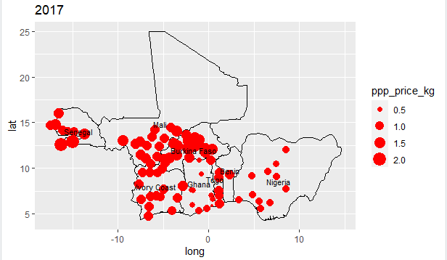

Your job is to analyze the spatial distribution of fertilizer prices, keeping in mind the spatial law-of-one-price (LOP). It is likely that prices are poorly spatially integrated because of high transportation costs and government restrictions on fertilizer trade (e.g., as part of a national fertilizer subsidy program). You should examine the distribution of prices for 2011, 2014 and 2017 to determine the extent that the price differentials persist in the long run. You should also look for explanations for the price differentials, especially those which persist in the long run. Perhaps estimate the correlation between the price of fertilizer and distance to port to partially isolate the effect of transportation costs. Perhaps use Google Maps/Google Earth to determine if the town/city is likely to have high transportation costs due to

Check out fertilizer manufacturing in Africa <https://thebreakthrough.org/issues/food/expand-fertilizer-manufacturing-across-africa>

One might expect that the city of Djougou will have relatively low fertilizer prices